# Display and Insert Records Exercise

## Instructions for Setting Up the Week 9 Exercises

## 1. Create a New Folder:

## - In your local wp directory(that is in the **htdocs** directory of XAMPP), create a folder named week9.

## 2. File Placement:

## - Place all new files for the exercises inside the week9 directory.

## 3. Naming Conventions:

## - Ensure there are no spaces in any file or folder names.

## - Use only lowercase letters for naming folders and files.

## 4. Reasons:

## - Avoiding spaces and using lowercase helps ensure compatibility with web environments, including case-sensitive servers like those at RMIT.

You will be using the **country** table in the **destination** database (that you created last week) for displaying and inserting records.

The exercise aims to create a website that can display all records in the database table. Also, you should be able to add new records to the table.

Create a web page to display all records in the country table. Show only the image and the country name. Add a link “Read More”, you will be using this link to display selected record details. Leave the *href* attribute empty for now.

Style this page with css.

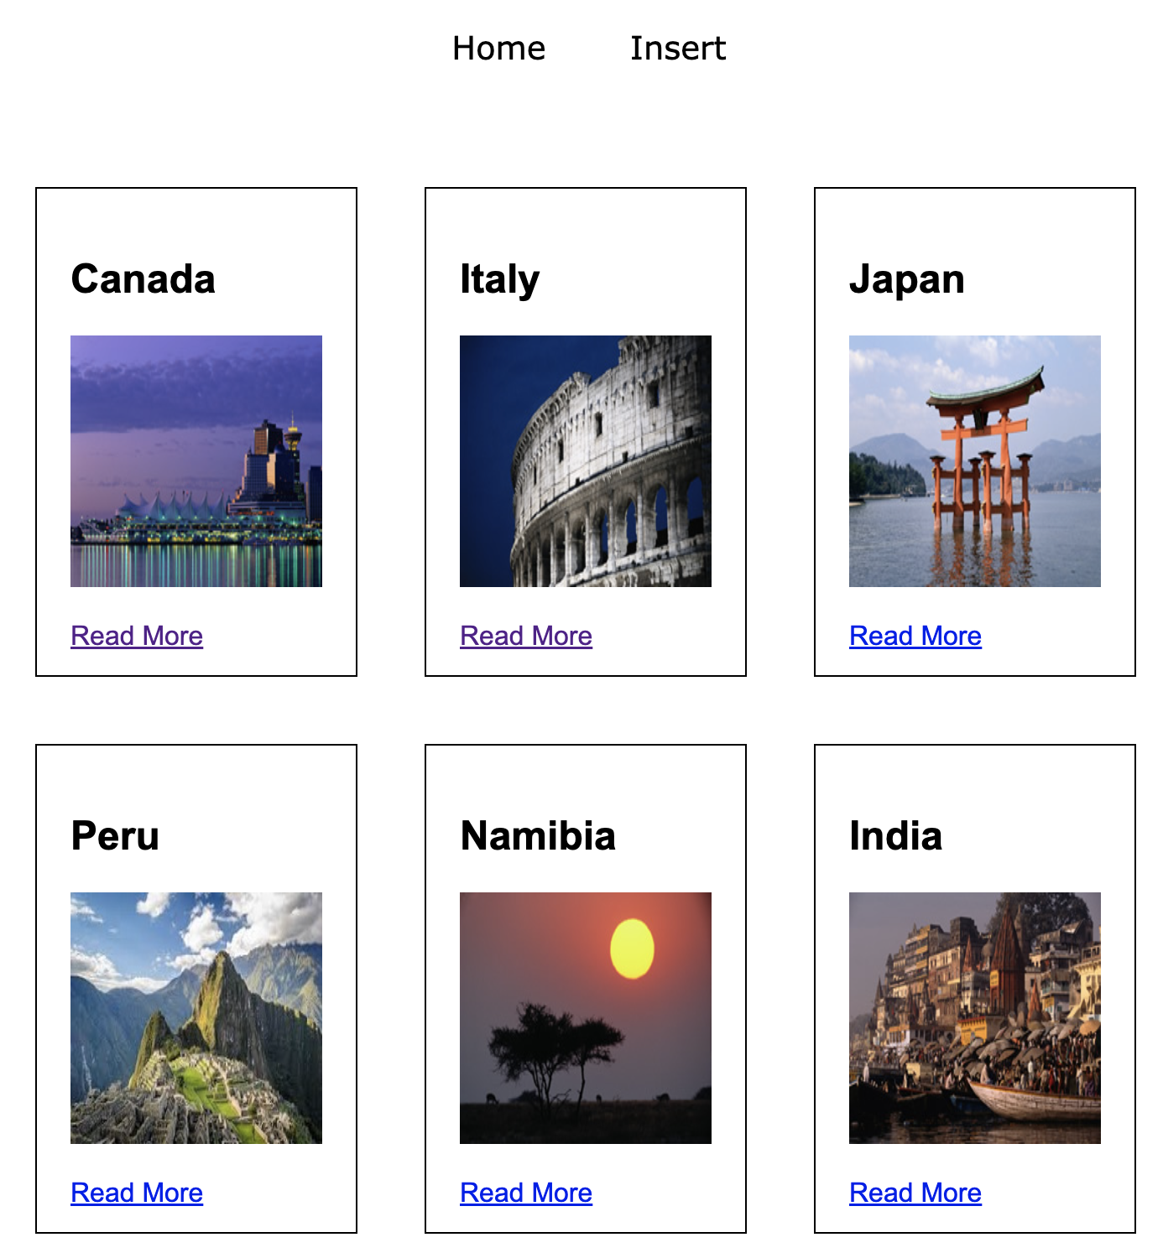

Create a page with a form to add a country record to the table. This form also has to upload a country image and save the name of the image in the table. You will also need to create a processing script for the form. Make sure that you test the process – add a record, find it in the table, image in the correct folder. Check that the newly added record is correctly displayed on the *index.html* page.

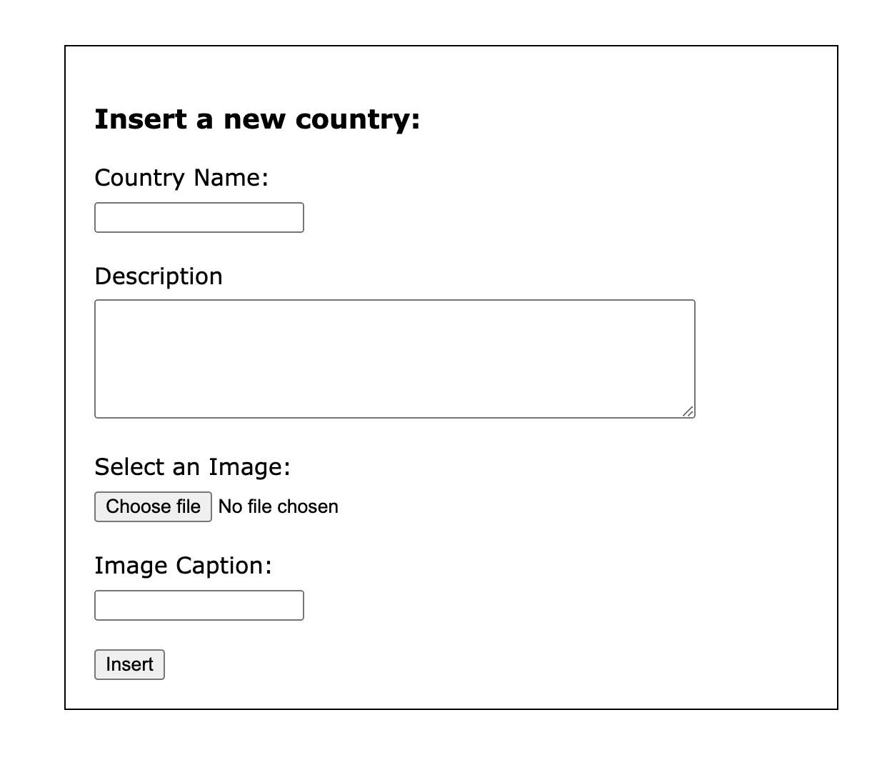

In total you will need the following files:

1. index.php with all countries
2. insert_form.php with the form for adding a new country
3. insert.php script to process submitted data
4. nav.inc for navigation between the two pages – “Home” and “Insert”
5. header.inc will contain all “starting” html tags up to (including) <body>
6. footer.inc will contain a footer element with copyright text and closing tags for body and html elements
7. db_connect.inc for creating a connection to the database
8. style.css with required styles
9. images folder for uploaded records images

Validate the resulting html for every page and the style.css file.

Transfer files to Jupiter and test your site with Jacob 5 database. Fix any errors.

## Committing Exercise Files to Git via Visual Studio Code

1. **Open Your Project in VS Code**:

- Launch VS Code.

- Open your project folder (**week9**) by going to File > Open Folder and selecting your project directory.

2. **Stage Your Changes**:

- In VS Code, go to the Source Control panel (the icon looks like a forked branch on the sidebar).

- You'll see a list of untracked/changed files. Hover over the "Changes" section and click the '+' icon to stage all changes, or stage individual files by clicking the '+' icon next to each file.

3. **Commit the Changes**:

- After staging, type a commit message in the input box at the top of the Source Control panel. Follow best practices for commit messages (clear, concise, and descriptive).

- Click the Commit button and select “Commit & Sync” (you can also use “Commit & Push”)

## Deploy Code to the RMIT webserver

1. Open Terminal or Command Prompt:

- On your local machine, open your terminal or command prompt.

2. SSH into the Server:

- Use the command **ssh s1234567@titan.csit.rmit.edu.au** where s1234567 is your student ID

- Enter your RMIT password.

3. Navigate to the **wp** Directory:

- Once connected, navigate to the directory where your Git repository is located on the server using **cd ~/public_html /wp**.

4. Pull the Latest Changes:

- Run the command **git pull origin main** to pull the latest changes from the remote repository.

5. Exit SSH Session (optional):

- After pulling the changes, you can end your SSH session by typing **exit**